1. **Patient**: One patient can have many visits, so the relationship between the Patient and Visit tables is one-to-many.
2. **Visit**: One visit can have one patient and one doctor, so the relationship between the Visit and Patient table is one-to-one, and the relationship between the Visit and Doctor table is one-to-one.
3. **Doctor**: One doctor can have many visits and many work assignments, so the relationship between Doctor and Visit tables is one-to-many, and the relationship between Doctor and Work Assignment tables is one-to-many.
4. **Treatment**: One treatment can be associated with one visit and one doctor, so the relationships between Treatment and Visit tables, and between Treatment and Doctor tables are both one-to-one.
5. **Medication**: One medication can be associated with one visit, so the relationship between Medication and Visit tables is one-to-one.
6. **Department**: One department can have many work assignments, so the relationship between Department and Work Assignment tables is one-to-many.
7. **Employee**: One employee can have many work assignments, so the relationship between Employee and Work Assignment tables is one-to-many.
8. **Work Assignment**: One work assignment can be associated with one employee and one department, so the relationships between Work Assignment and Employee tables, and between Work Assignment and Department tables are both one-to-one.

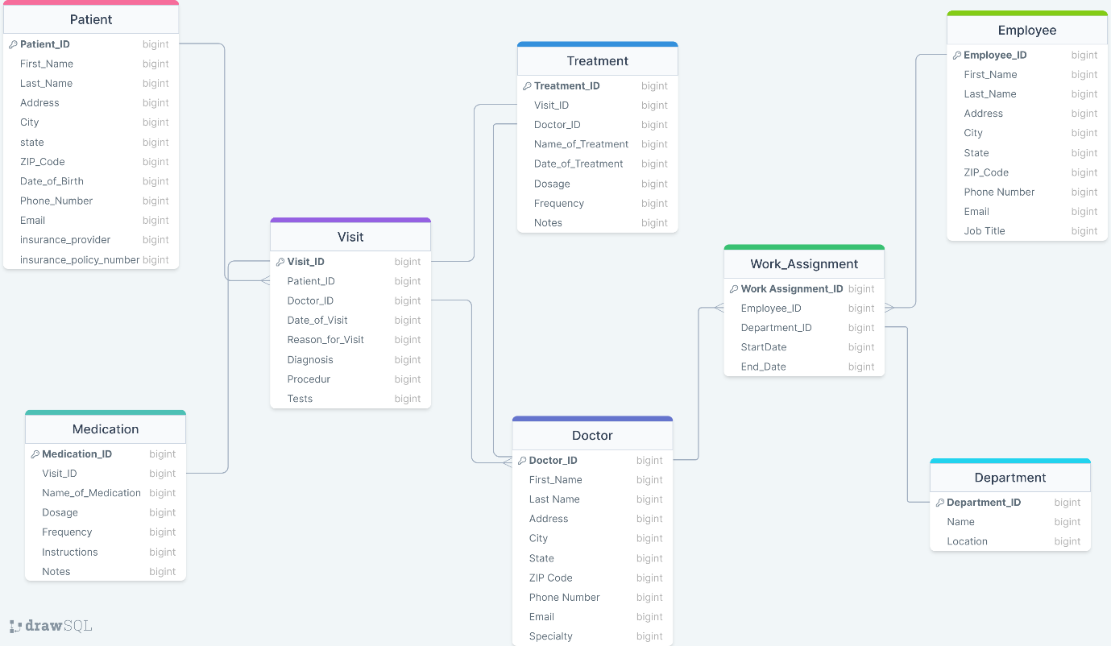

<https://drawsql.app/teams/a-429/diagrams/hospital>

that diagram link